

**FACE-DETECTITION**

**USING AWS**

**Submitted by-**

**ABHILASH K BIRADAR**

1. **AWS LOGIN SCREEN WITH USERNAME**

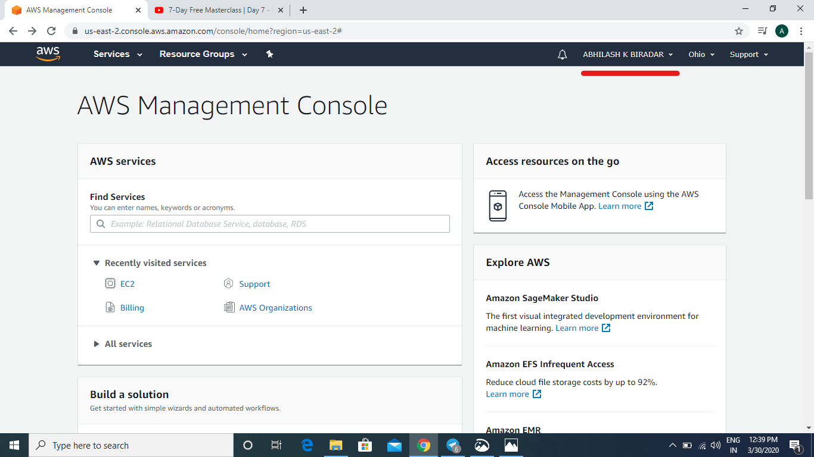

**SCREEN SHOTS OF EC2**

1. **EC2 DASHBOARD**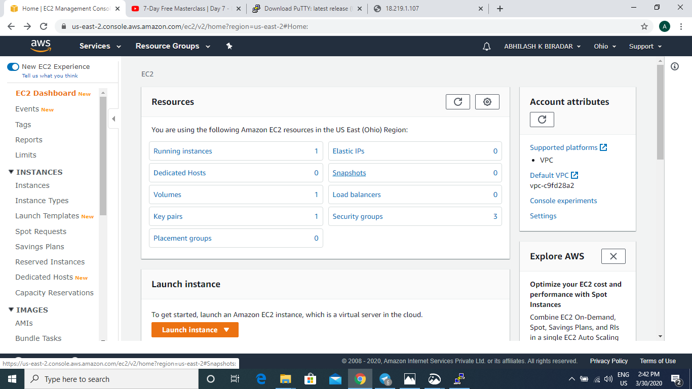
2. **CHOOSING AN AMI** 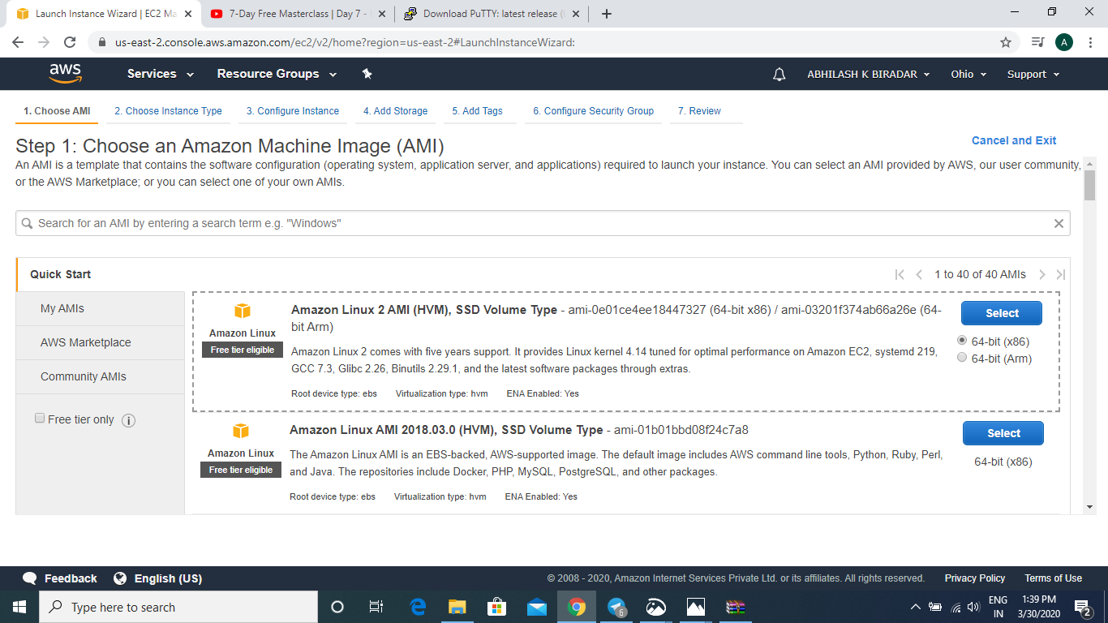
3. **CHOOSING AN INSTANCE TYPE**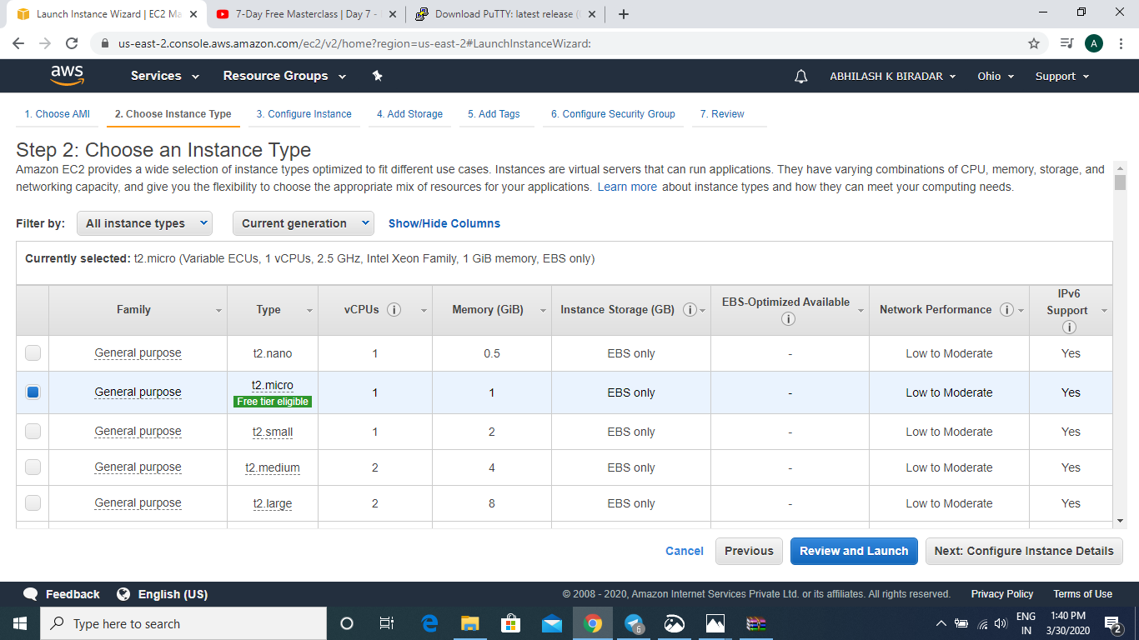
4. **ADDING STORAGE**

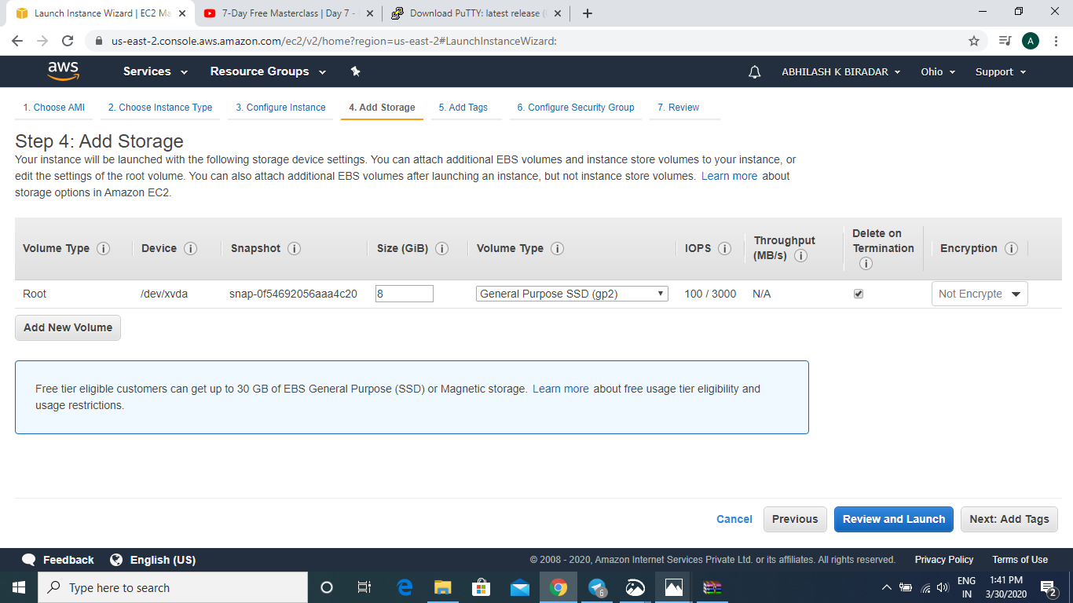

1. **CONFIGURING SECURITY GROUP**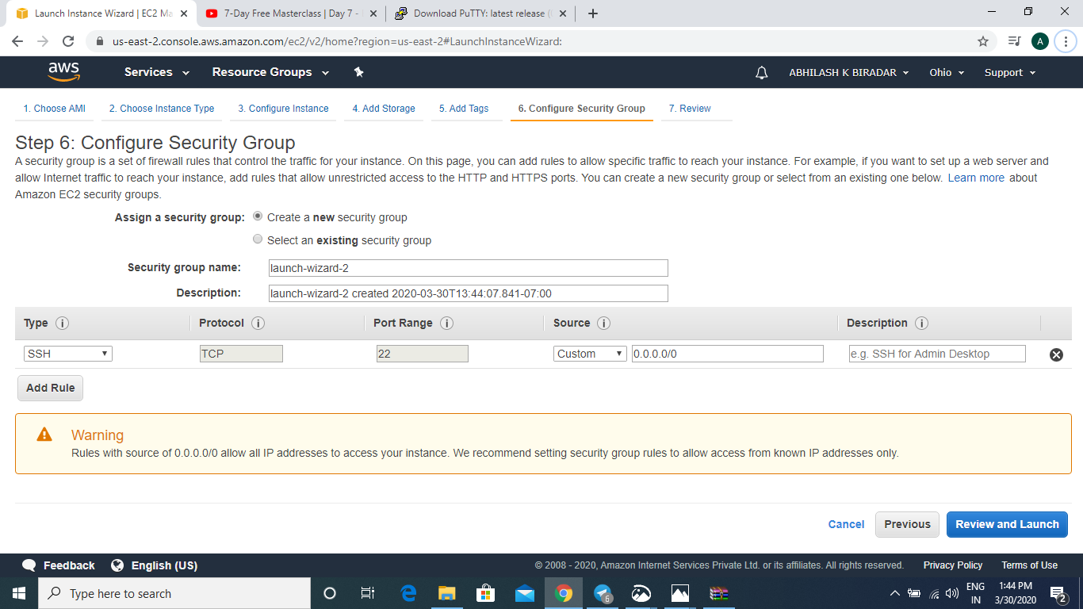
2. **KEY PAIR DOWNLOAD**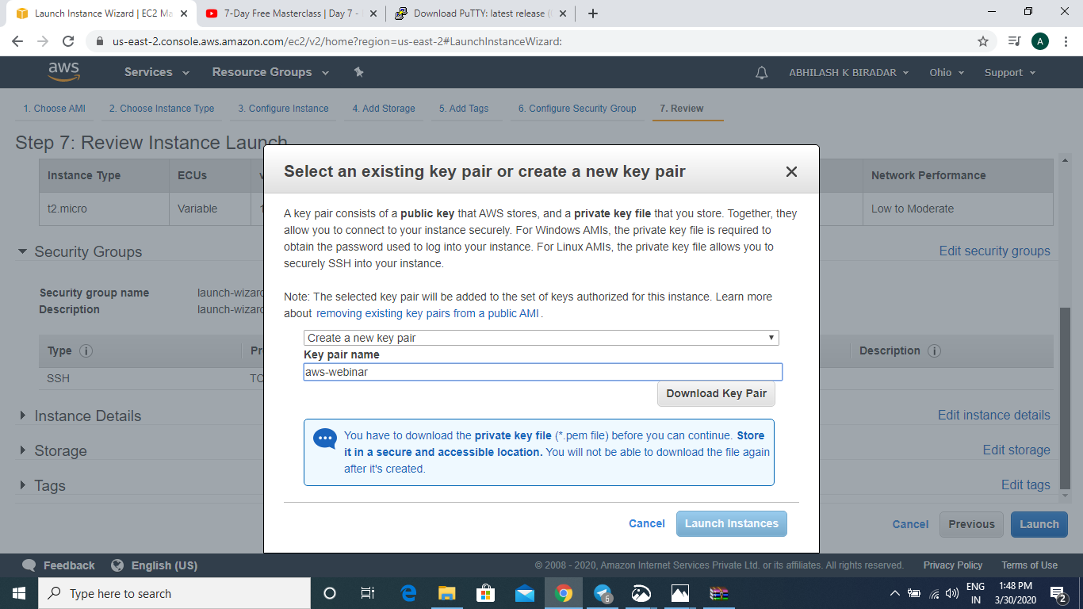
3. **PuTTYGEN CONVERSION FILE FROM PEM TO PPK**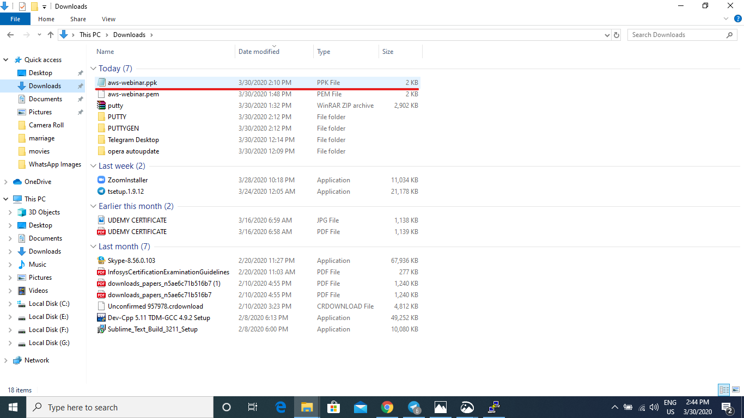
4. **LOGGED IN EC2 BLACKSCREEN**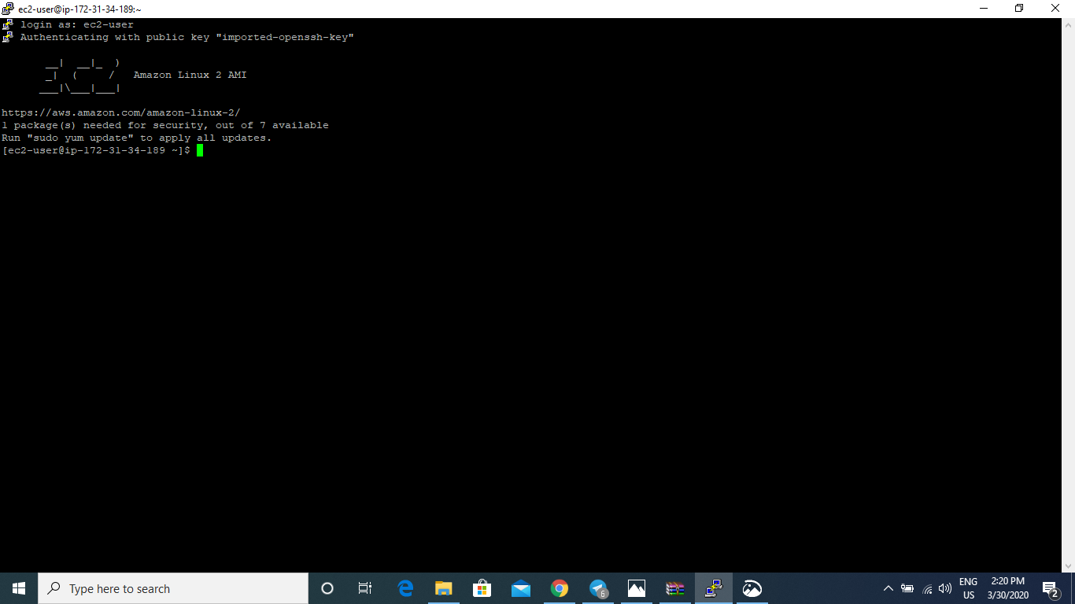
5. **CONNECTED TO SERVER**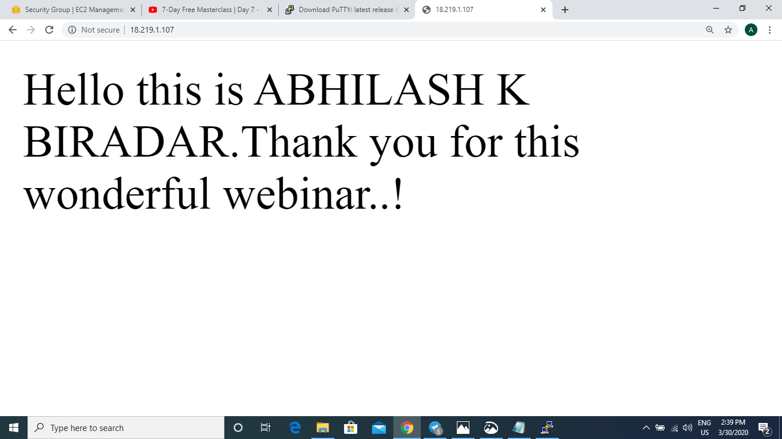

**SCREEN SHOTS OF S3**

1. **S3 DASHBOARD**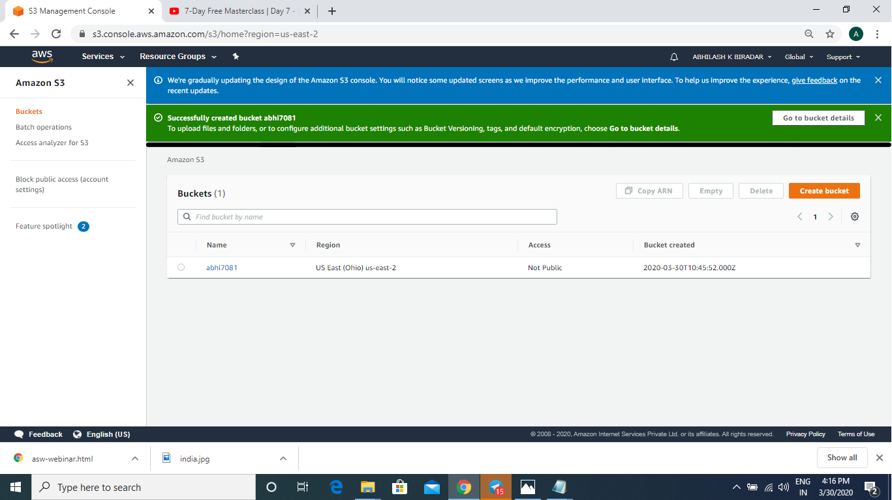
2. **CREATING A BUCKET**
3. **UPLOADING AN OBJECT**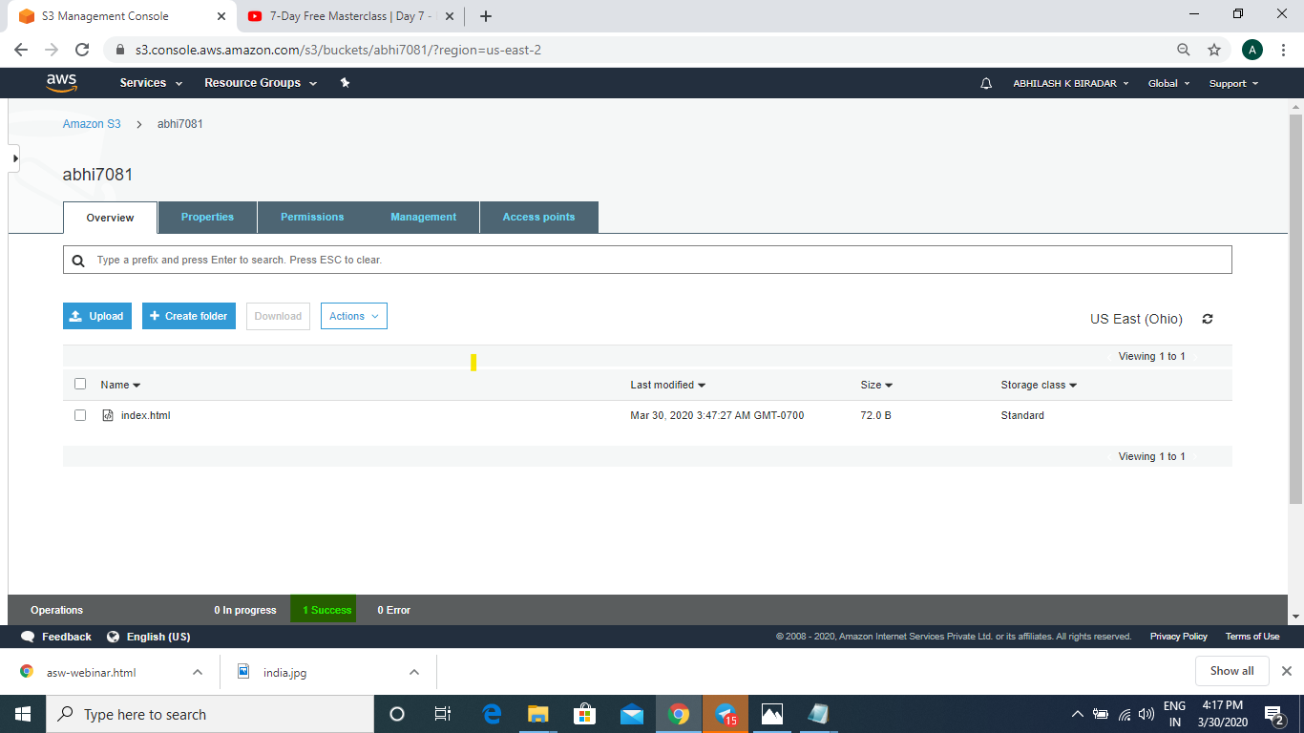
4. **ENABLING A STATIC WEBSITE**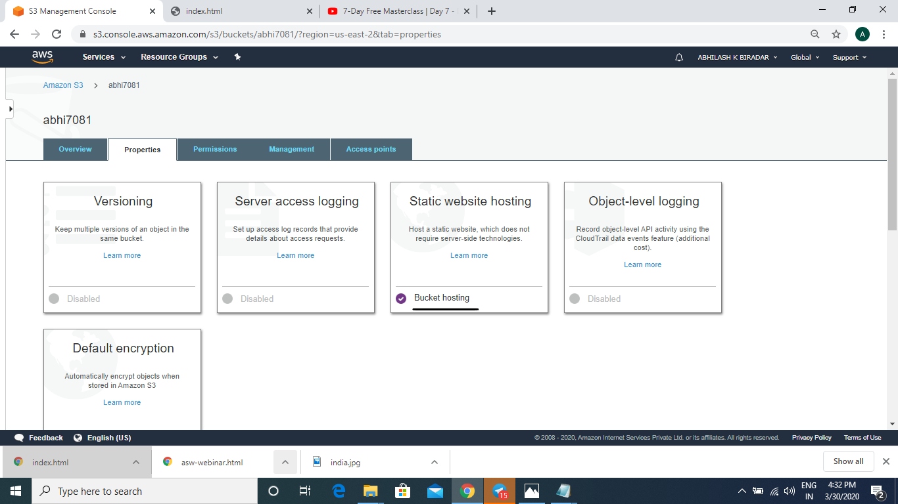
5. **MAKING THE OBJECT PUBLIC**

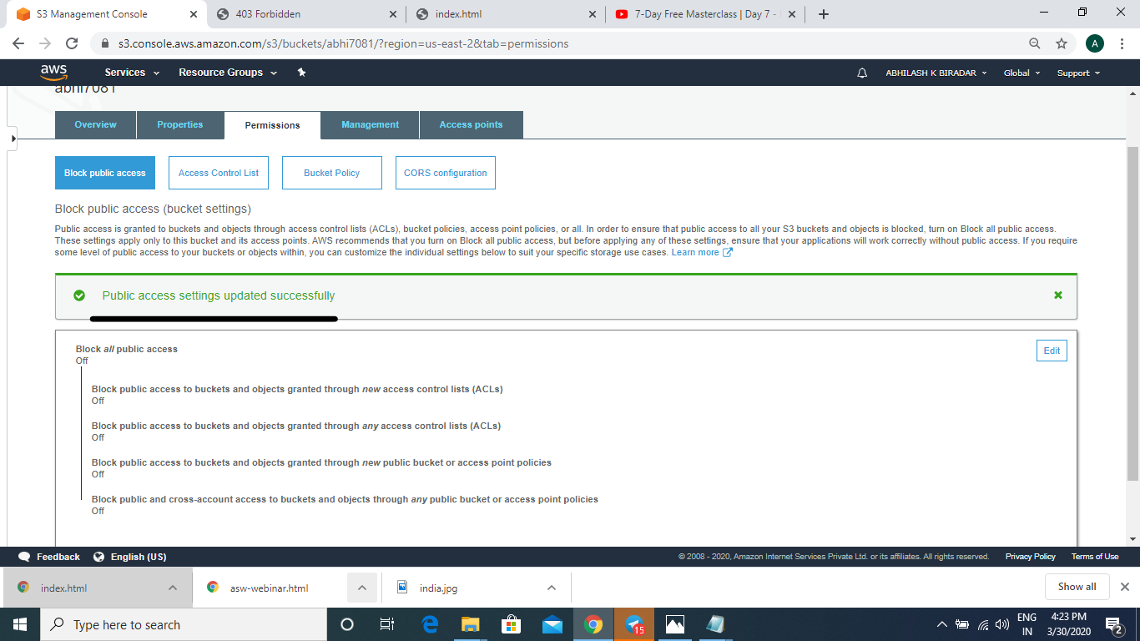

1. **CHECKING THE S3 LINK ON THE BROWSER**

**SCREEN SHOTS OF REKOGNITION**

1. **REKOGNITION DASHBOARD**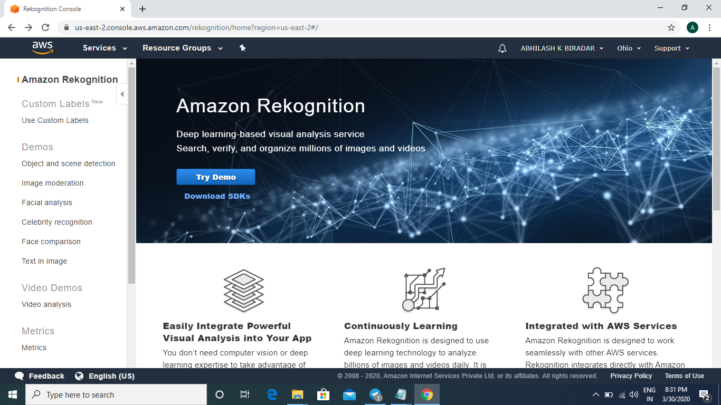
2. **FACE DETECT**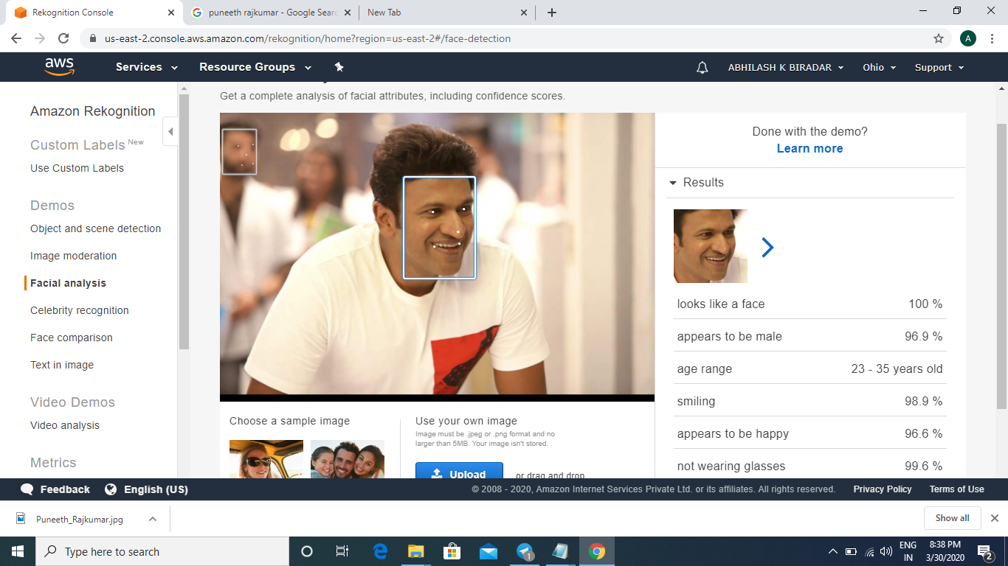
3. **FACE COMPARE**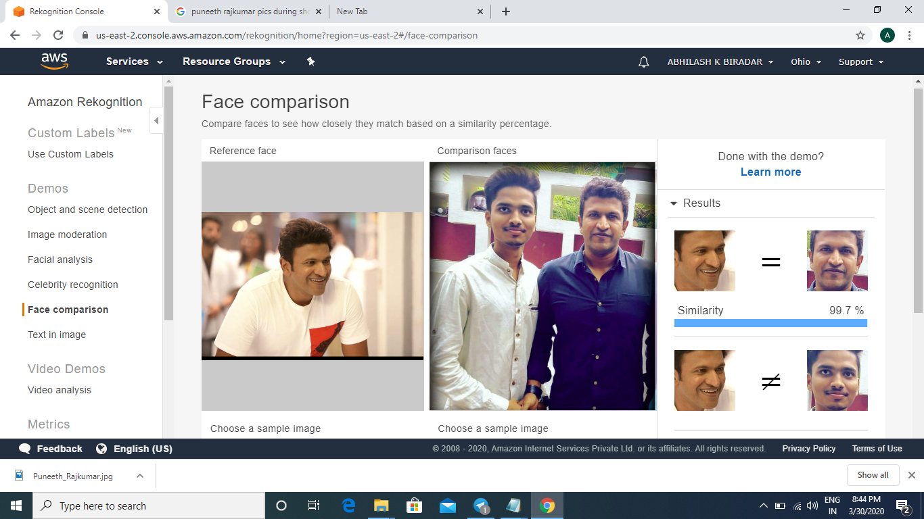
4. **CELEBRITY RECOGNITION**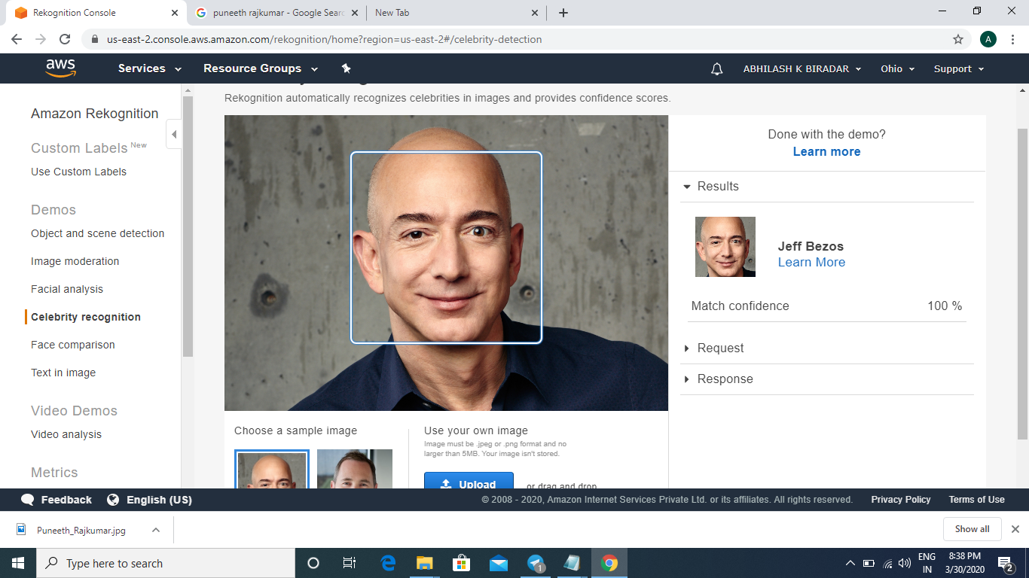
5. **TEXT IN IMAGE**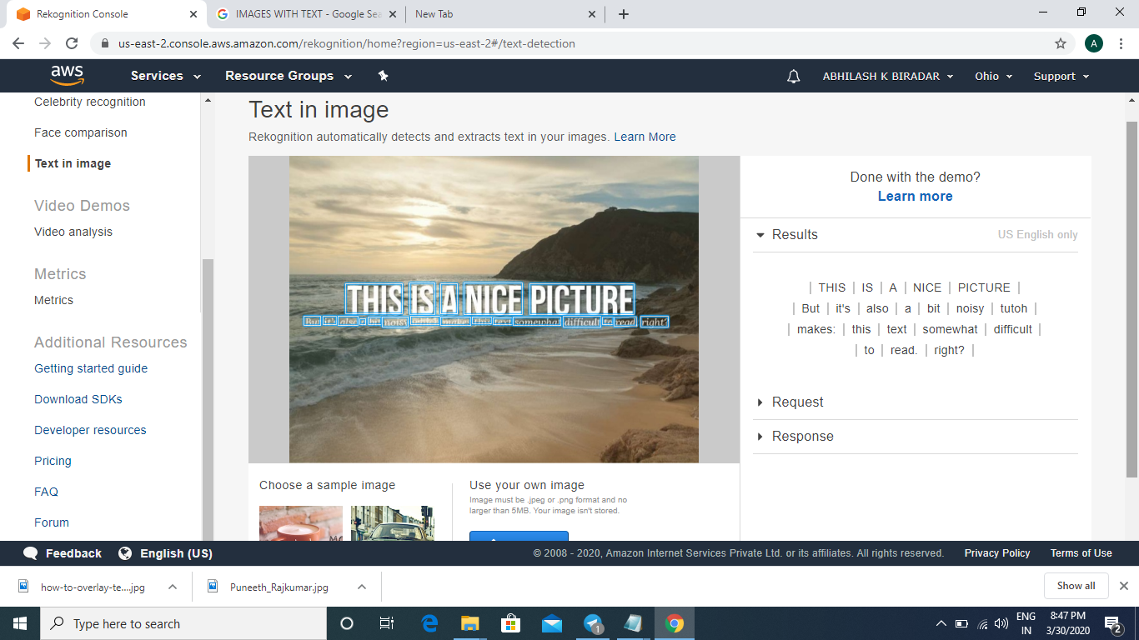

**SCREEN SHOTS OF EC2 AND S3**

1. **INSTALLING AWS-SDK**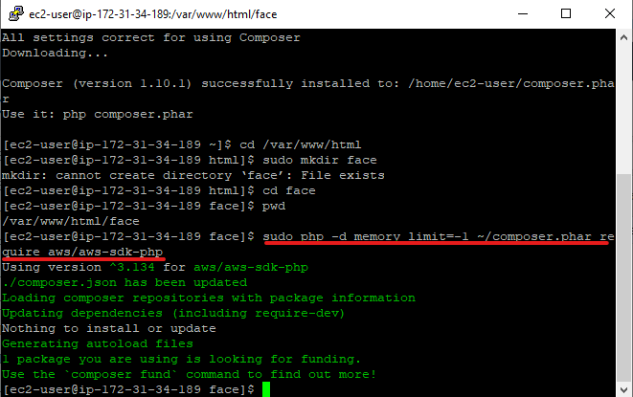
2. **INSTALLING PHP**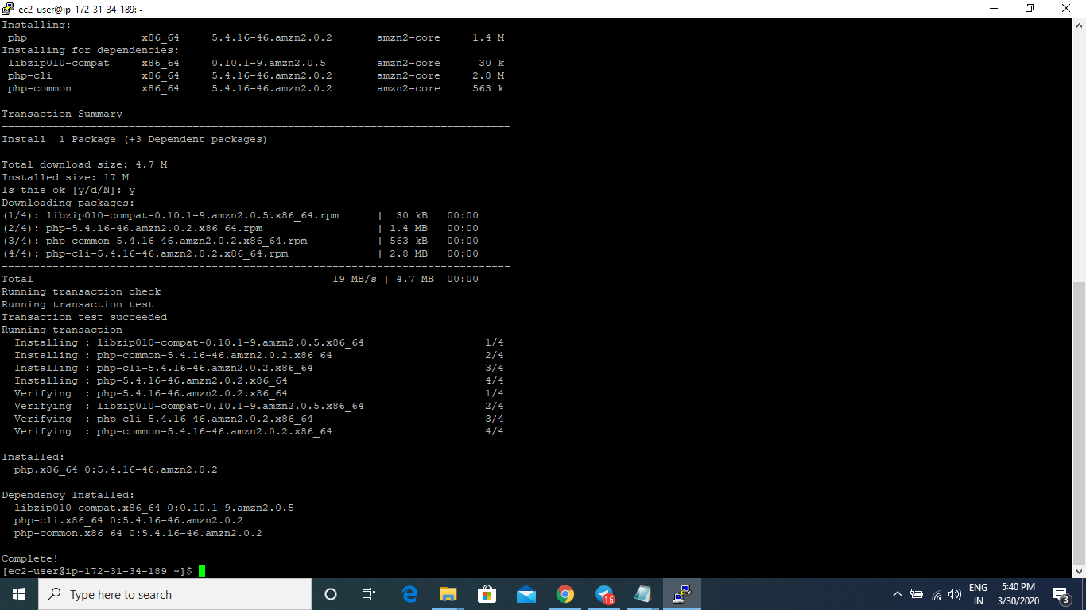
3. **INDEX.PHP FILE CODE**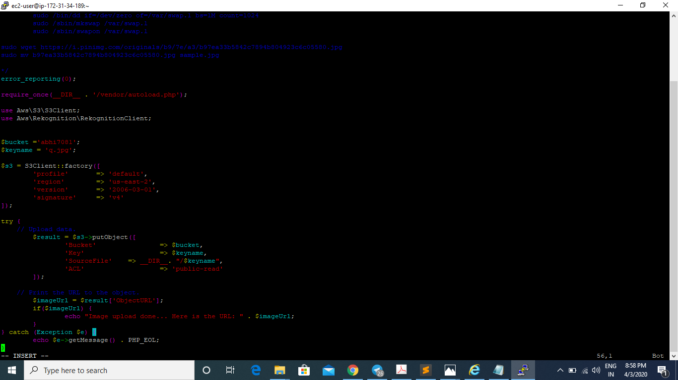
4. **IMAGE IS SAVED**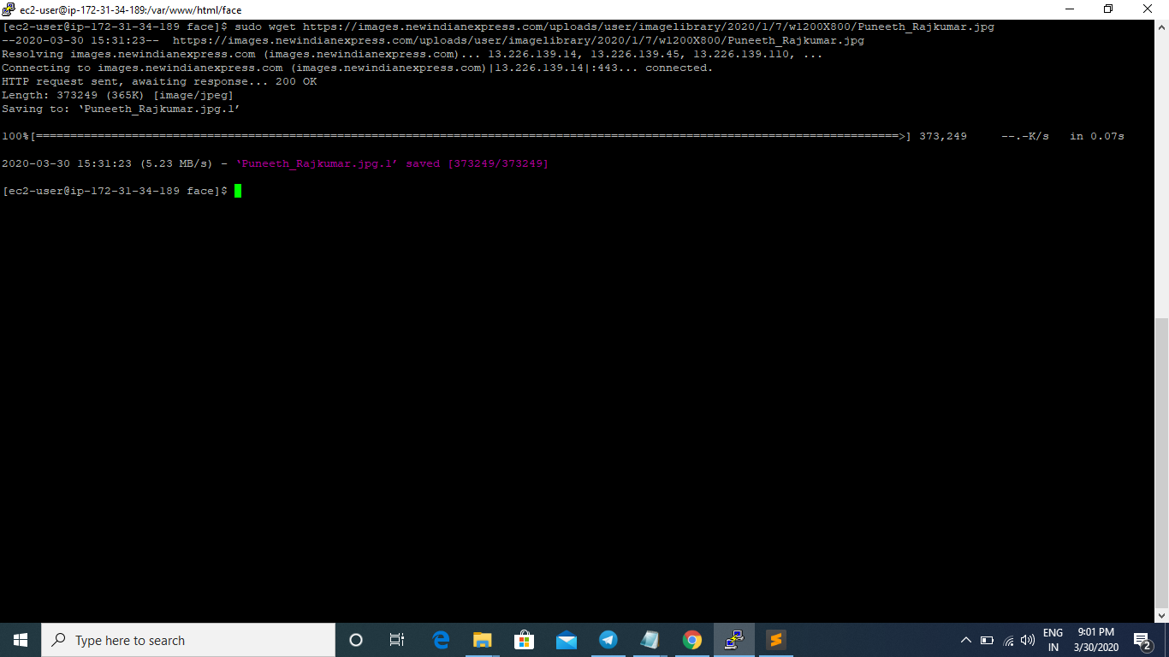
5. **IMAGE UPLOAD SUCCESS**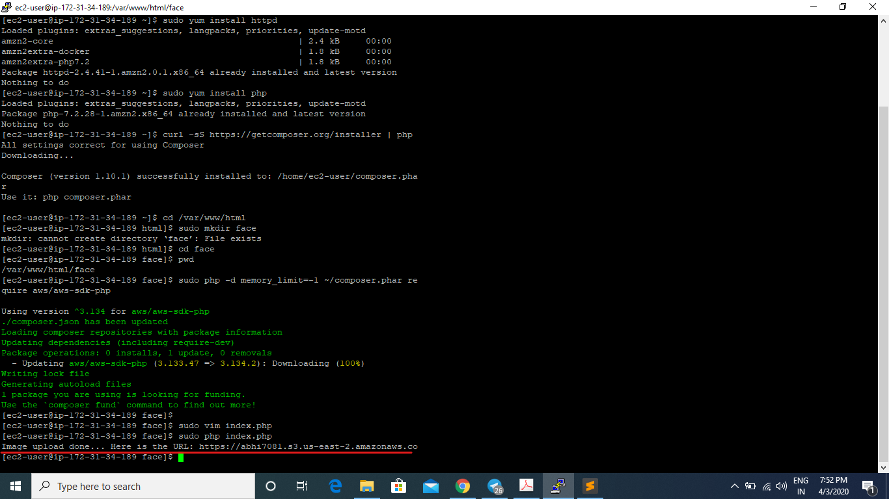
6. **UPLOADED IMAGE OPENED IN BROWSER USING URL**

**SCREENSHOTS OF EC2 AND REKOGNITION**

1. **PHP CODE FORE REKOGNITION**

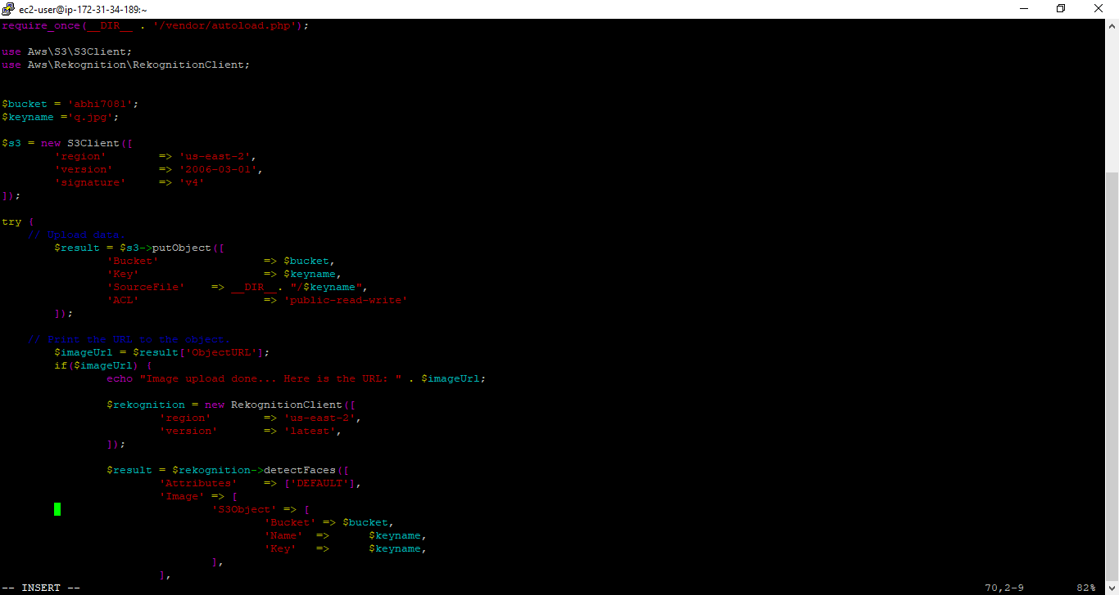

1. **FACE DETECT SUCCESS**